A Practical activity Report submitted

for Engineering Design Project-II (UTA-024)

by

**Vanshikaa 102103580**

**Submitted to**

**Dr.Jaswinder Kaur**



**DEPARTMENT OF ELECTRONICS AND COMMUNICATION ENGINEERING**

**THAPAR INSTITUTE OF ENGINEERING AND TECHNOLOGY, (A DEEMED TO BE UNIVERSITY), PATIALA, PUNJAB**

**INDIA**

**Jan-May 2023**

**TABLE OF CONTENT**

|  |  |  |
| --- | --- | --- |
| **Sr. No.** | **Experiment no.** | **Objective** |
| **1** | **1 (a)** | To draw a schematic diagram of pulse width modulation (PWM) based transmitter for generating specified pulse width waveforms for gantries placed at different locations on the path using CAD tool (Eagle). |
| **2** | **1 (b)** | To design a printed circuit board layout of pulse width modulation (PWM) based transmitter circuit using CAD tool (Eagle). |
| **3** | **2 (a)** | To draw a schematic diagram of receiver to receive specified pulse width IR signals from gantries using CAD tool (Eagle). |
| **4** | **2(b)** | To design a printed circuit board layout of receiver circuit using CAD tool (Eagle). |
| **5** | **3 (a)** | To draw a schematic diagram of IR sensor module circuit (required to move Buggy module on a predefined the path) using CAD tool (Eagle). |
| **6** | **3 (b)** | To design a printed circuit board layout of IR sensor module circuit using CAD tool (Eagle). |
| **7** | **4** | To solder and test a pulse width modulation (PWM) based transmitter circuit (for gantries placed at different locations on the path to be followed by Buggy robot) on a printed circuit board (PCB). |
| **8** | **5** | To solder and test pulse width modulation (PWM) based receiver circuit (to receive IR signals from gantries connected to transmitter circuit) on a printed circuit board (PCB). |
| **9** | **6** | To solder and test an IR sensor module circuit (which helps Buggy robot to move on a predefined path) on a printed circuit board (PCB). |

**Experiment: 1**

**Objective:**

1. To draw a schematic diagram of pulse width modulation (PWM) based transmitter for generating specified pulse width waveforms for gantries placed at different locations on the path using CAD tool (Eagle).
2. To design a printed circuit board layout of pulse width modulation (PWM) based transmitter using CAD tool (Eagle).

**Software Used:** Eagle Software

**Component Used:**

|  |  |  |  |
| --- | --- | --- | --- |
| **Sr. No** | **Name of Components** | **Value** | **Specifications** |
| 1. | Resistor | 220 Ω | Carbon Resistor with 5% Tolerance |
| 2. | Capacitor | 1000nF | Electrolytic Capacitor |
| 3. | Capacitor | 10nF | Electrolytic Capacitor |
| 4. | DCJ0202 |  | DC Power Jack |
| 5. | HLMP6 | 5V | Dome Lamp |
| 6. | IC 78L05Z | +5V | Positive Voltage Regulator |
| 7. | 22-23-2031 |  | PCB Header |
| 8. | PIC12F629 |  | Microcontroller |

**Theory :**

**1.Resistor**:Resistors are electronic components with the primary functions to limit the flow of electric current. There are lot of different resistor types all with there own applications and characteristics and construction. Fixed resistors have a constant resistance value and they are the most common type. Variable Resistor have an adjustable resistance value. Most variable resistors are adjusted by mechanical movement when they are used as a variable voltage divider they are called potentiometers.

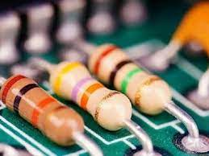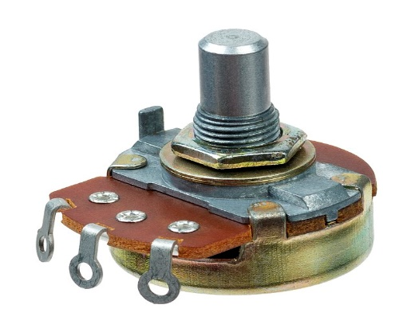

**Various types of resistors [1]**

2. **Capacitor**: The capacitor is a component which stores electric charge. It is like a battery except it stores energy in a different way. It cannot store as much energy as battery, although it can charge and release its energy much faster. This is very useful, and i.e. you will find capacitors used in almost every circuit board. We measure the capacitance of a capacitor in the unit of Farads.

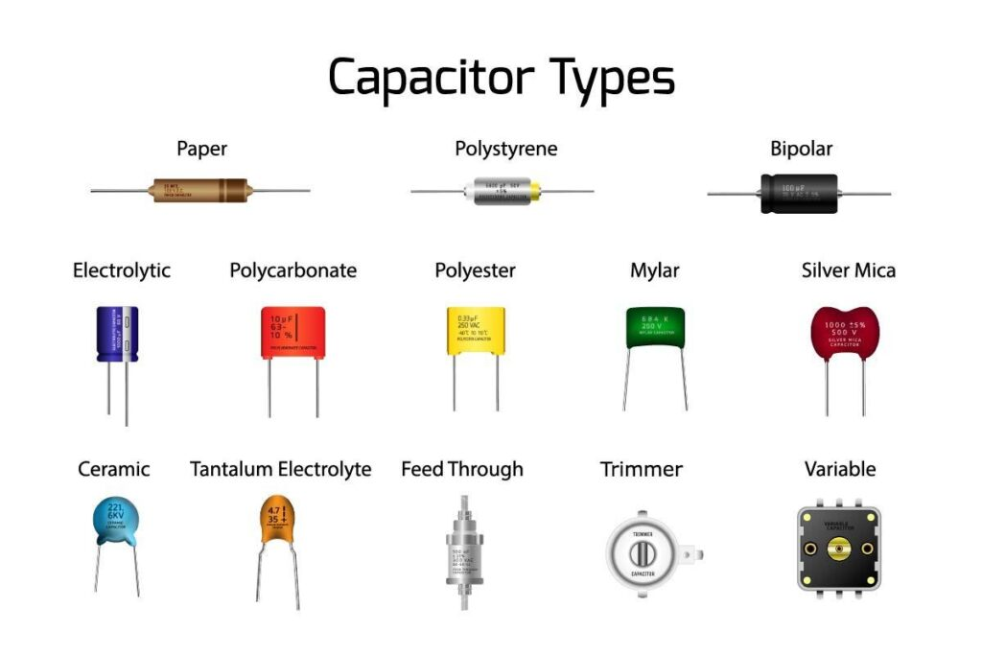

**Various types of capacitors [2]**

3. **HLMP6**: HLMP 6 is a sub miniature standard red LED lamp with tinted or diffused lens. All of these devices are made by encapsulating LED chips on axial lead frames to form a molded poxy sub-miniature lamp package. A variety of package configuration options is available. These include special surface mount lead configurations, gull wing, yoke lead or Z-bend.

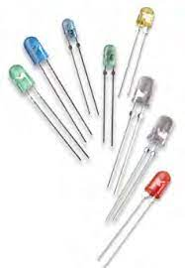

**Various types of sub miniature standard LED [3]**

4. **IC 78L05Z**: 78L05Z is a fixed positive voltage regulator. It has three terminals. The three terminals are Input, Output and ground as shown in the 78L05 pinout diagram. It is very easy and straight forward to use this IC, just connect the input in to the input voltage which has to be regulated and the ground pin to system ground.

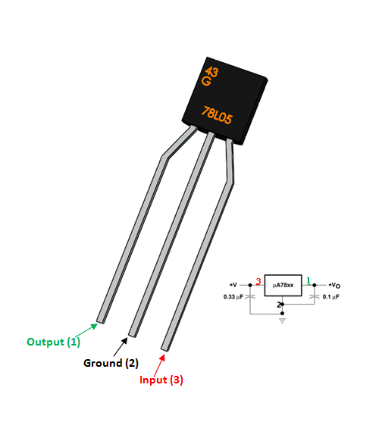

Voltage regulator 78L05Z [4]

5. **PIC12F629**: PIC12F629 is a powerful easy to program CMOS. This powerful (200 nanosecond instruction execution) yet easy-to-program (only 35 single word instructions) CMOS Flash-based 8-bit microcontroller packs Microchip’s powerful PIC MCU architecture into an 8-pin package and features 1 channel comparator and 128 bytes of EEPROM data memory. This device is easily adapted for automotive, industrial, appliances and consumer entry-level product applications that require field re-programmability.

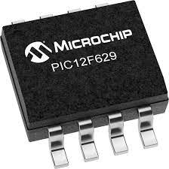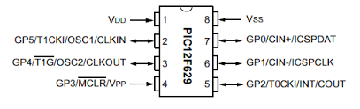

IC PIC12F629 [5]

6.**DCJ0202**: This is a common barrel-type power jack for DC wall supplies. These are compatible with our DC wall supplies and have a 5.5mm jack, with a 2.1mm diameter of centre pole.

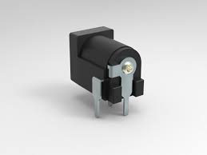

IC PIC12F629 [6]

7. **22-23-2031**: 22-23-2031 is a 2.54 mm pitch wire to board connectors. It is a 3 circuit KK 254 solid header with friction lock mates with mates with 2695, 6471, 7880, 4455, 7720.

**Schematic diagram:**

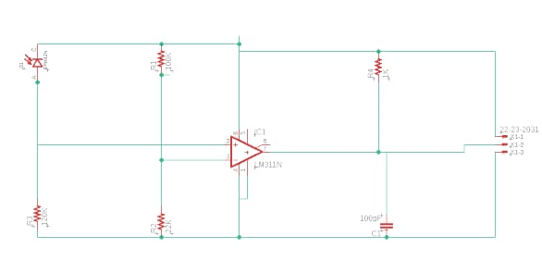

Schematic diagram of Transmitter circuit

**Printed Circuit Board layout:**

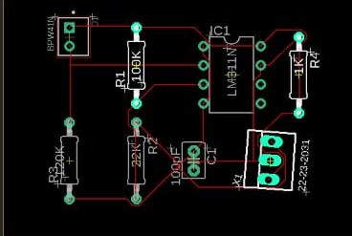

PCB layout of Transmitter circuit

**Discussion:**

In this experiment, we have used the Eagle software to draw a schematic diagram as well as circuit board layout of receiver circuit. We studied about the various functionalities of components like LM311N (Op-Amp Comparator) and MBD701 (Schottky Diode).

**Reference:**

**[1]** https://www.theengineeringknowledge.com/how-variable-resistors-work/

**[2]** <https://components101.com/regulators/78l05-pinout-equivalent-datasheet#:~:text=The%2078L05%20is%20a%20three,ground%20pin%20to%20system%20ground>.

**[3] https://en.wikipedia.org/Voltage-Regulator**

**[4]https://en.wikipedia.org/wiki/Light-emitting_diode**

**[5]**[**https://components101.com/IC12F629**](https://components101.com/IC12F629)

**[6]** [**https://components101.com/IC12F629**](https://components101.com/IC12F629)

**Signature of Faculty member**